LOL_issue_1

1. Log is as SM;
2. Choose the line with status “Approved by PM”;
3. Delete it.

Actual result: SM can delete the line with Status “Approved by PM”

Expected result: SM can’t delete the line with Status “Approved by PM”

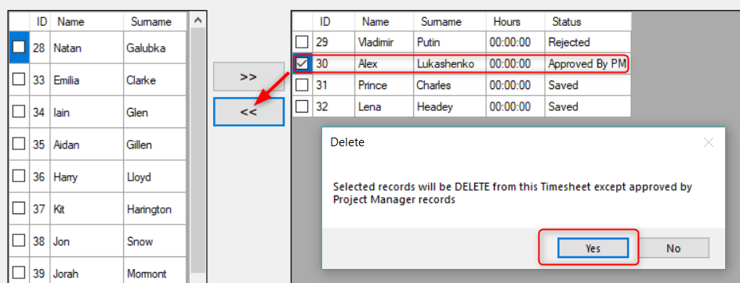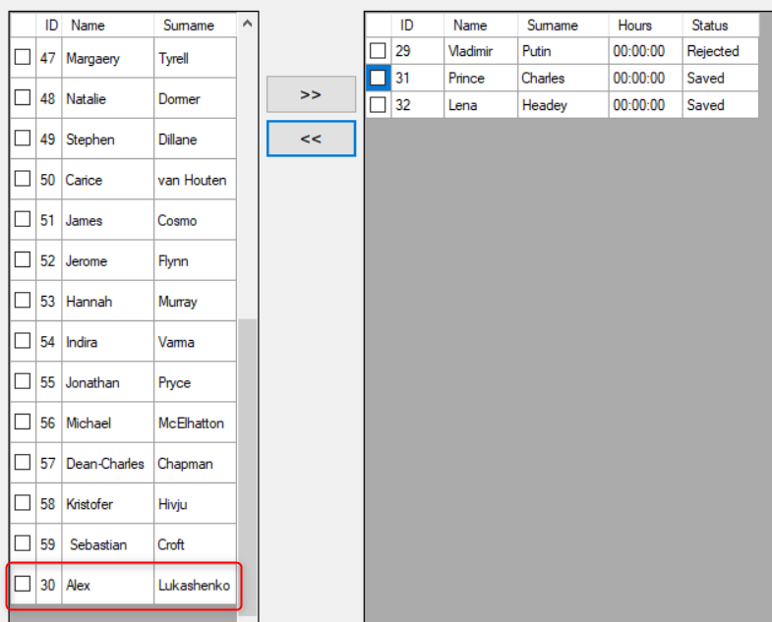

Resolution:

if (((bool)dataGridViewTS.Rows[i].Cells[0].FormattedValue) && dataGridViewTS.Rows[i].Cells[4].ToString() != "Approved by PM")

Was changed to:

if (((bool)dataGridViewTS.Rows[i].Cells[0].FormattedValue) && (dataGridViewTS.Rows[i].Cells[5].Value.ToString() != "Approved By PM"))

